**Experiment 1:**

**AIM: Installing Vagrant & Creating basic vagrant box using Virtual Box**

**virtualization.**

1. Download and Install Oracle Virtual Box 5.x and Vagrant 2.2.7.

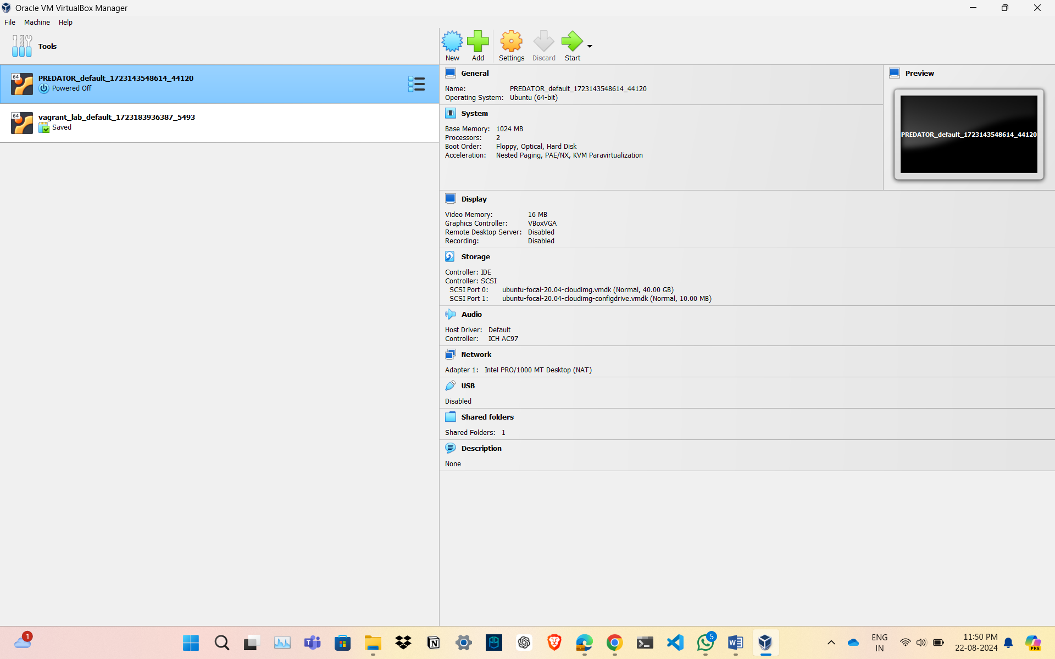

1. Check working of Vagrant using vagrant --version command.

Command vagrant –version

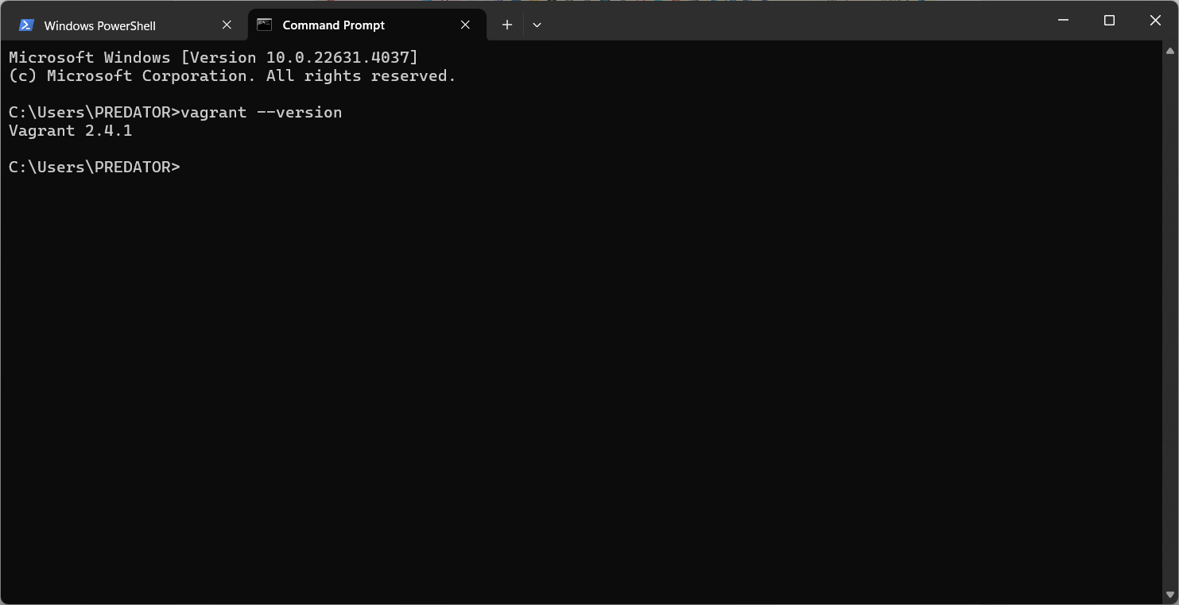

1. Create a new directory using CMD.



1. Run vagrant init command

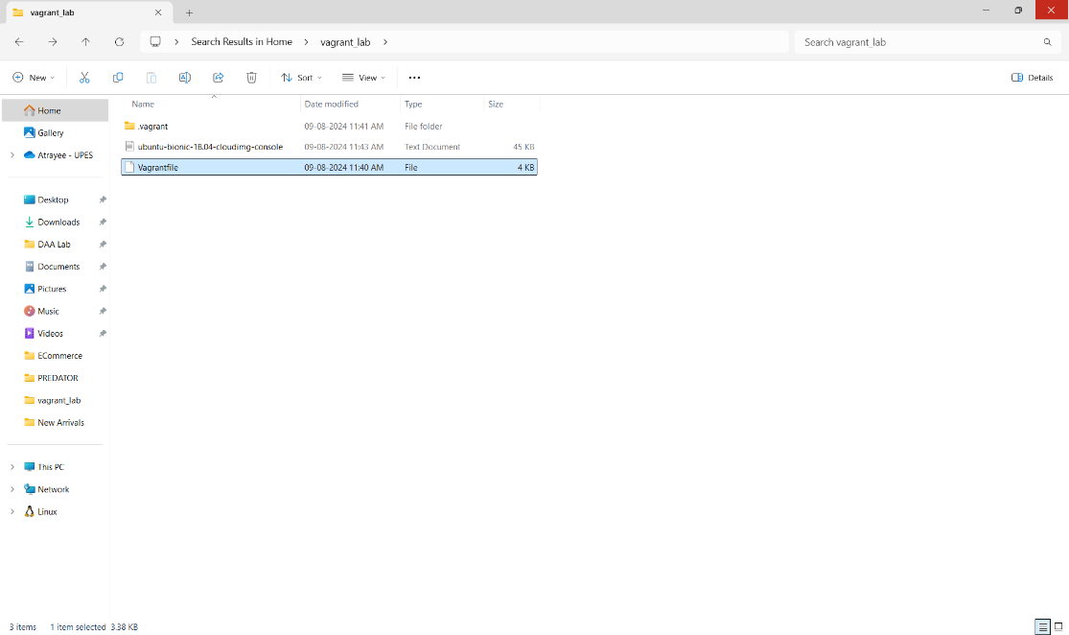

1. Edit vagrantfile and add ubuntu/xenial64 in box tag.

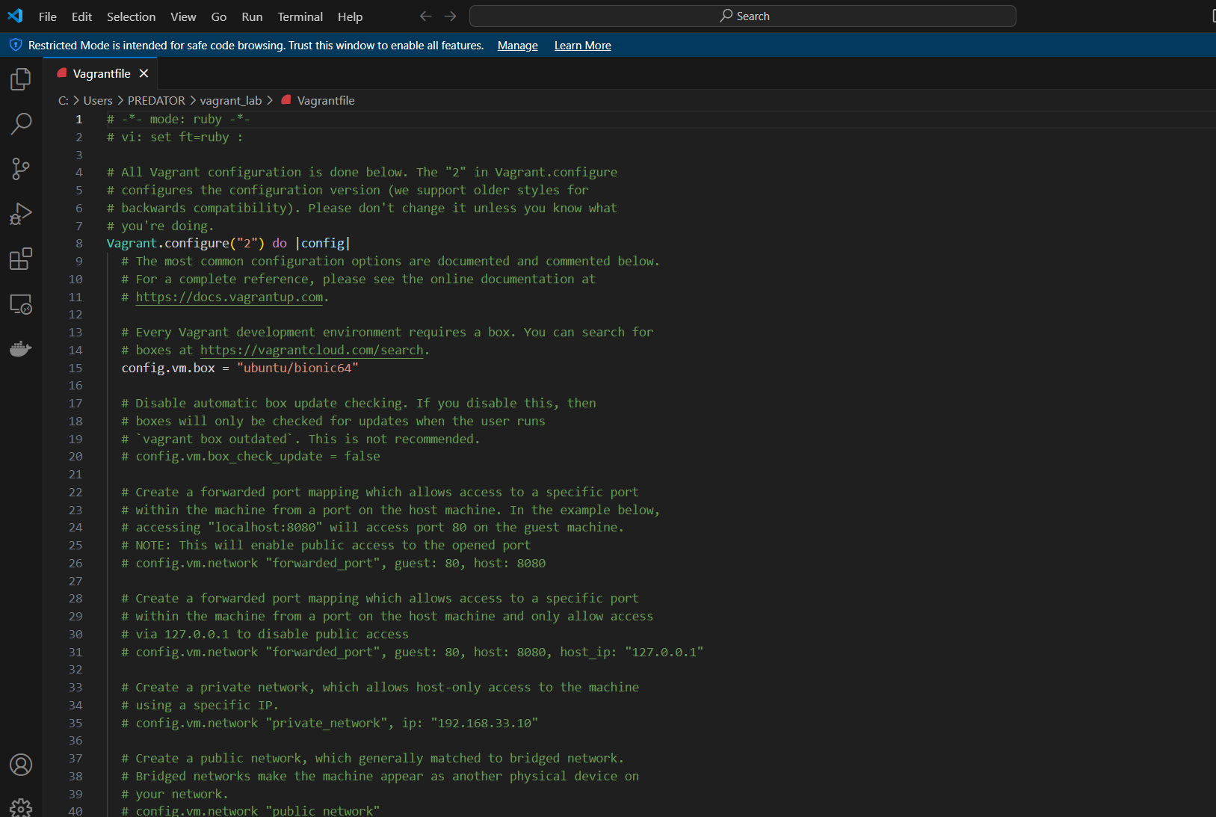

1. Run vagrant up command

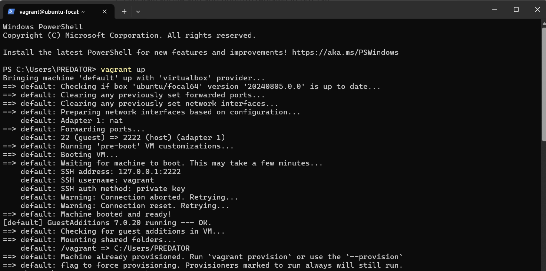

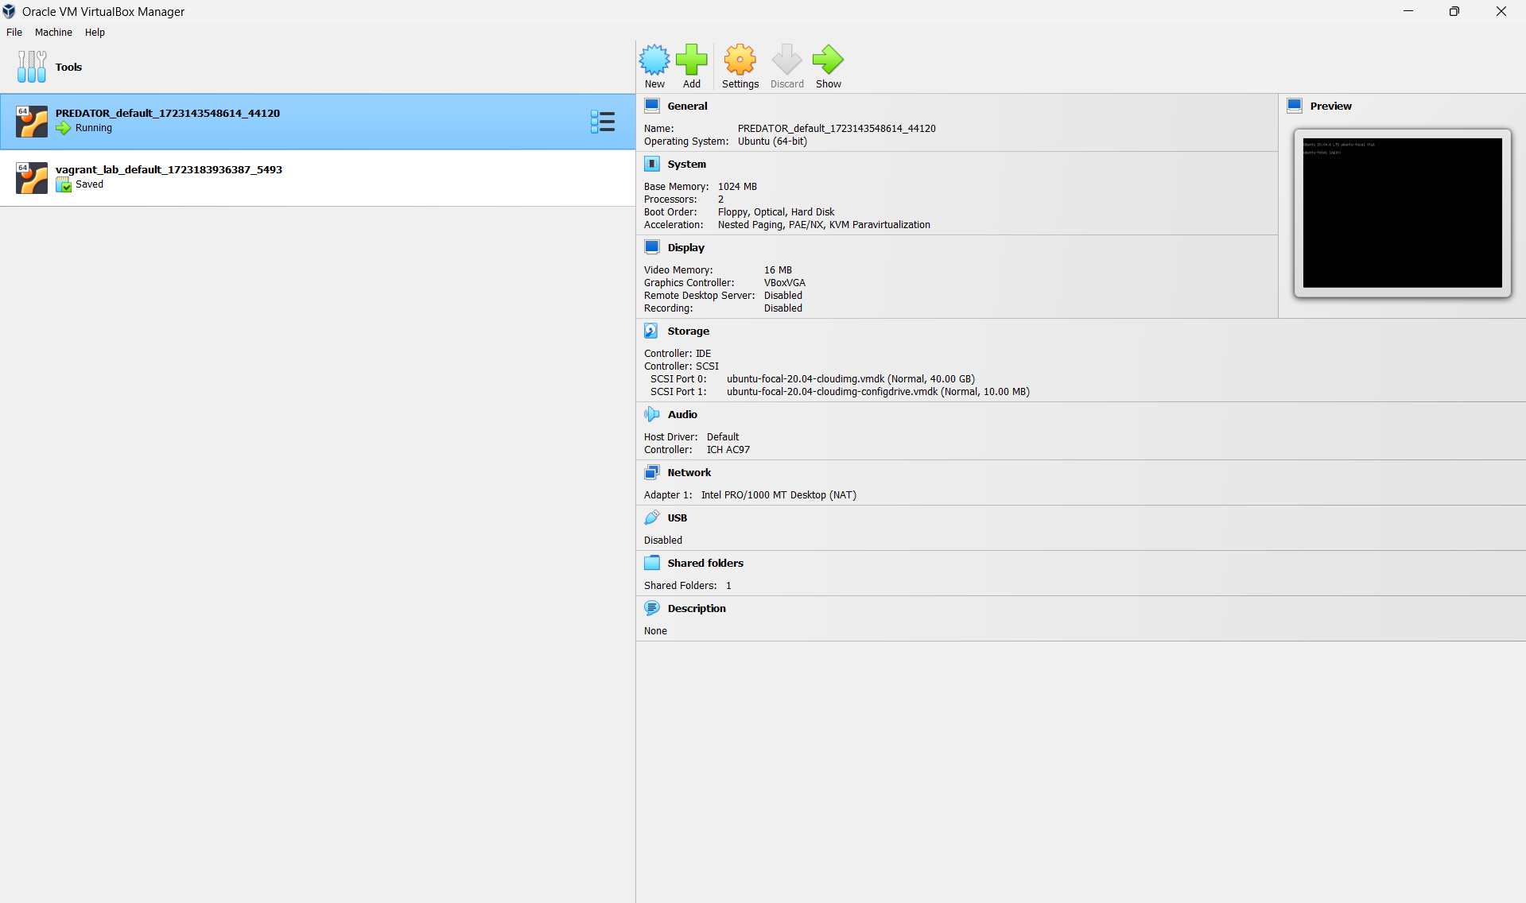

1. Run vagrant SSH command

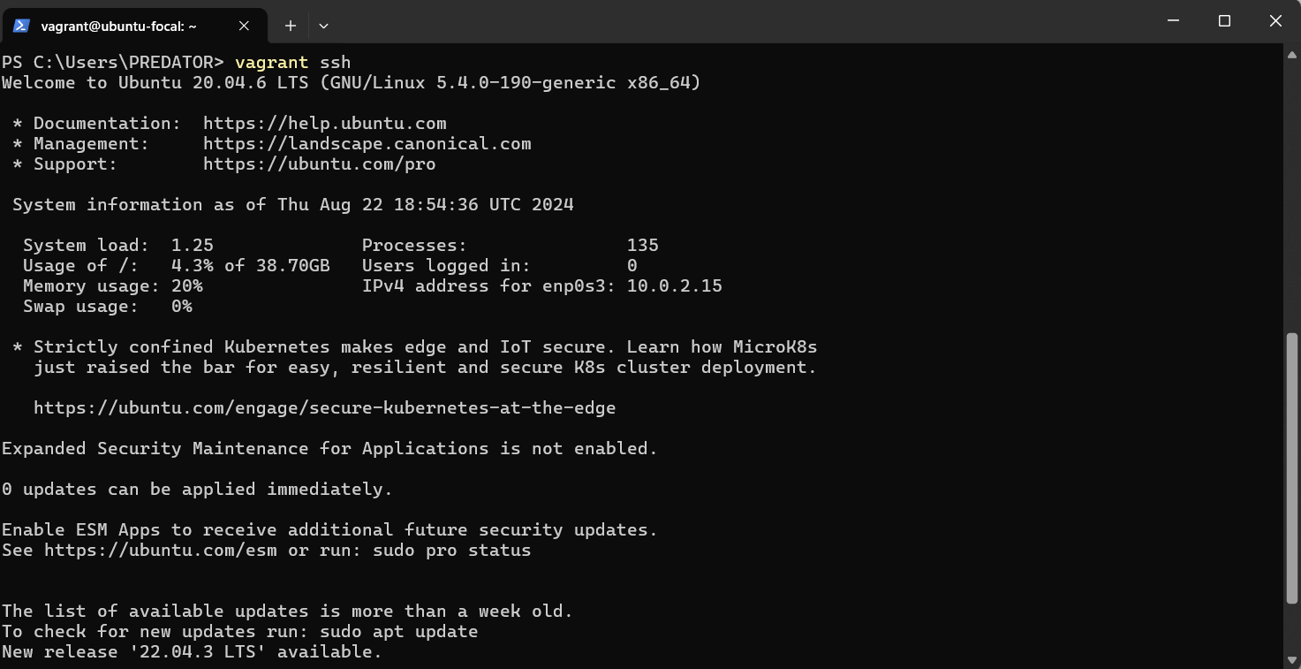

1. Run Vagrant Halt to stop VM

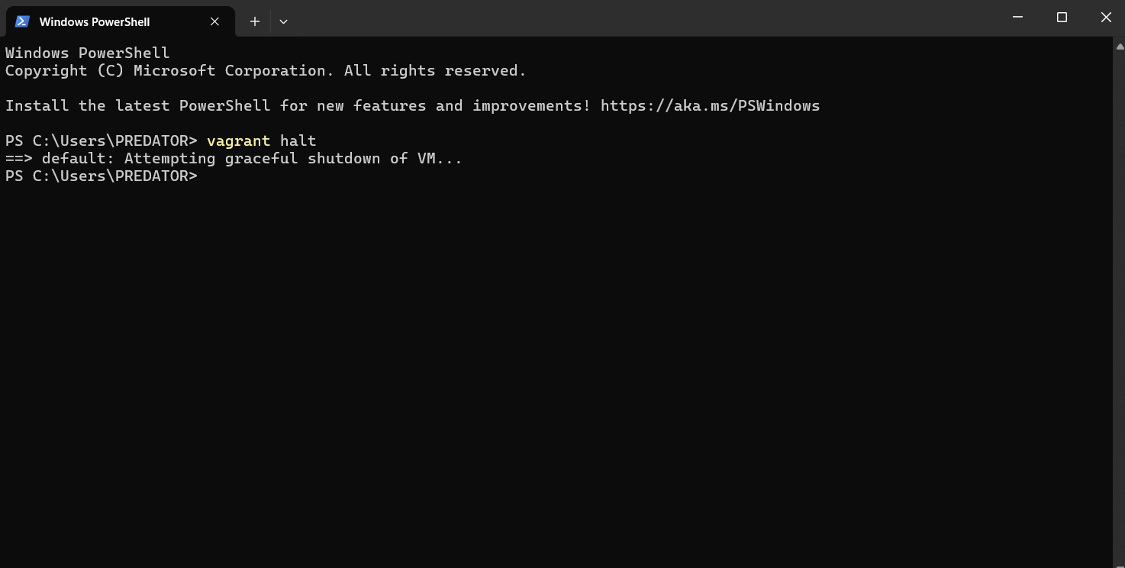

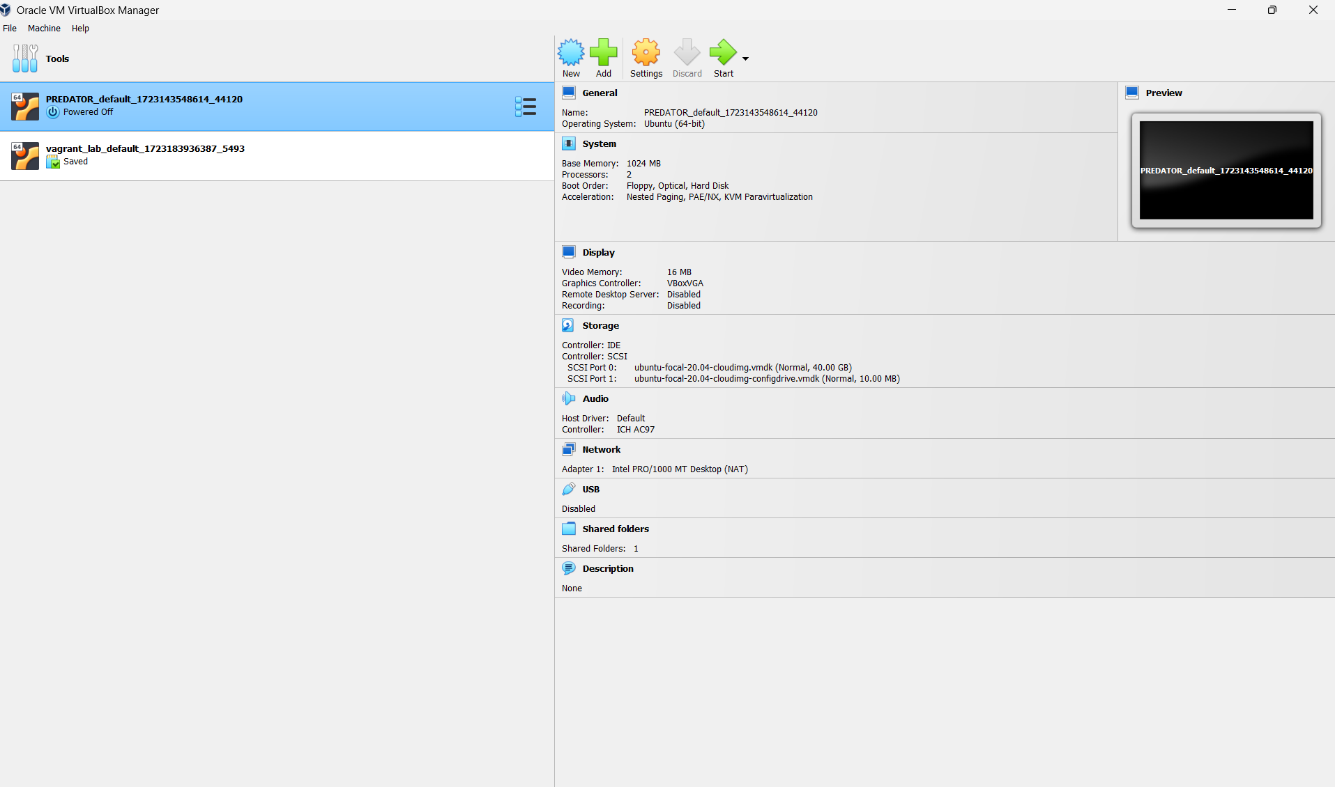

1. Run Vagrant Destroy to delete VM

